Research Paper Title: Customer Segmentation and Churn Pattern Analytics in European Banking: A Data-Driven Approach to Customer Retention

ABSTRACT
This project focuses on Customer Segmentation and Churn Pattern Analytics in European Banking using data analytics and customer segmentation techniques. The primary objective of the study is to analyze customer churn behavior across different demographic, geographic, and financial segments and identify groups that are more likely to leave the bank. The dataset contains customer information such as credit score, geography, gender, age, tenure, account balance, number of products, credit card ownership, activity status, and estimated salary.
Exploratory Data Analysis (EDA) and segmentation-based analytics were performed to evaluate churn patterns among different customer groups. Customers were segmented based on geography, age groups, credit score bands, tenure categories, and balance levels. Various visualizations and Key Performance Indicators (KPIs) were developed to understand churn distribution and customer characteristics. The analysis revealed that customers from Germany, inactive members, older age groups, and high-balance customers exhibit relatively higher churn rates. The findings provide valuable insights for banks to design targeted retention strategies, improve customer engagement, and reduce customer attrition.

INTRODUCTION
Customer churn is one of the most significant challenges faced by the banking industry. Churn occurs when customers discontinue their relationship with a bank and switch to competing financial institutions. Customer attrition not only affects revenue generation but also increases customer acquisition costs and reduces long-term profitability. Therefore, understanding customer churn patterns has become essential for banks seeking sustainable growth and customer retention.
With the advancement of data analytics, banks can leverage customer information to identify high-risk customer segments and understand the factors contributing to churn behavior. Customer segmentation plays a crucial role in this process by grouping customers based on common characteristics such as demographics, financial profile, geographic location, and engagement level. These insights enable banks to implement personalized marketing campaigns, improve customer satisfaction, and strengthen retention strategies.
This project analyzes customer churn patterns in European banking institutions using segmentation-driven analytics. The study investigates churn behavior across different customer segments and provides actionable insights for strategic decision-making.

METHODOLOGY AND CUSTOMER SEGMENTATION
The study utilized a European banking customer dataset containing demographic, financial, and behavioral information. The data was subjected to data cleaning, validation, and segmentation analysis to identify churn-prone customer groups.

Data Preparation
The following preprocessing activities were performed:
- Removal of non-analytical fields such as CustomerId and Surname.
- Validation of categorical and numerical variables.
- Verification of churn labels and activity indicators.
- Creation of customer segmentation categories.

Customer Segmentation Variables
The analysis was conducted using the following segmentation dimensions:
- Geographic Segmentation – France, Germany, Spain
- Age Segmentation – Below 30, 30-45, 46-60, Above 60 Years
- Credit Score Segmentation – Low credit, Medium credit, High credit Score
- Tenure Segmentation – New Customers, Mid-term Customers, Long-term Customers
- Balance Segmentation – Zero Balance, Low Balance, High Balance Customers

Analytical Techniques
The study employed:
- Exploratory Data Analysis (EDA)
- Customer Segmentation Analysis
- Churn Rate Calculation
- Comparative Demographic Analysis
- High-Value Customer Churn Analysis
- KPI-Based Performance Measurement

Key Performance Indicators (KPIs)
The following KPIs were developed:
- Overall Churn Rate
- Segment-wise Churn Rate
- Geographic Risk Index
- High-Value Customer Churn Ratio
- Engagement Drop Indicator
- Customer Distribution by Segment

RESULTS
The customer segmentation and churn analytics dataset consists of 10,000 banking customers from European countries. Among the total customers, 2,037 customers have exited the bank, resulting in an overall churn rate of 20.37%. This indicates that approximately one out of every five customers has discontinued their relationship with the bank. The observed churn rate highlights the importance of identifying high-risk customer segments and understanding the factors influencing customer attrition. These insights can help banks develop targeted retention strategies and improve long-term customer loyalty.

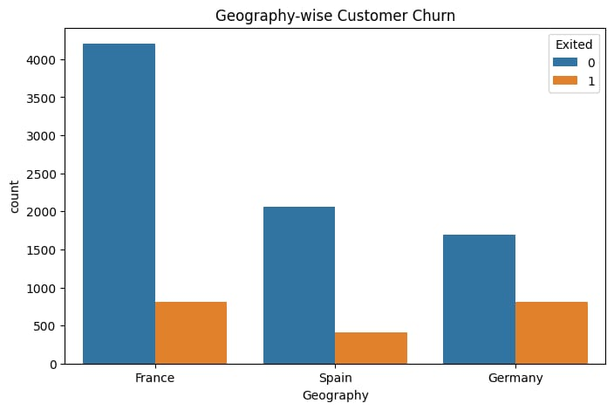
Interpretation
The chart illustrates the distribution of customers and churn across different countries. France has the largest customer base, while Germany and Spain have comparatively fewer customers. Despite having fewer customers, Germany records a higher proportion of churned customers. This indicates that customers in Germany are more likely to leave the bank than those in other regions. Therefore, Germany can be considered a high-risk market that requires stronger customer retention initiatives.

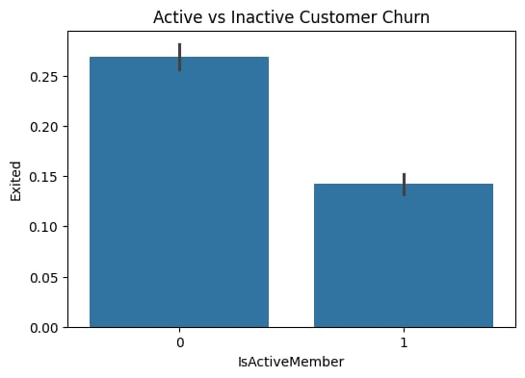

Interpretation
The chart compares churn behavior between active and inactive customers. It is evident that inactive customers account for a significantly larger share of churned customers. Active customers tend to maintain a stronger relationship with the bank and are less likely to leave. This highlights the importance of customer engagement and regular banking activity. Encouraging customer participation through personalized services may help reduce churn rates.

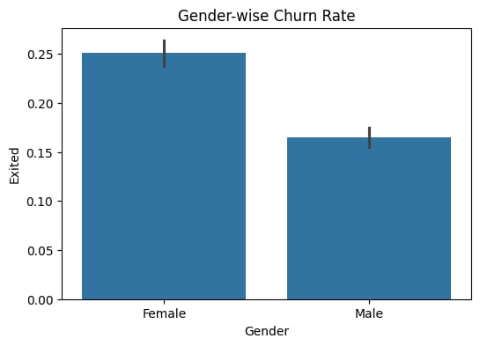

Interpretation
The chart presents the churn distribution among male and female customers. Female customers show a relatively higher churn rate compared to male customers. This suggests that female customers may be less satisfied or have different banking expectations. The difference indicates the need for gender-focused customer retention strategies. Understanding customer preferences can help the bank improve service quality and loyalty among female customers.

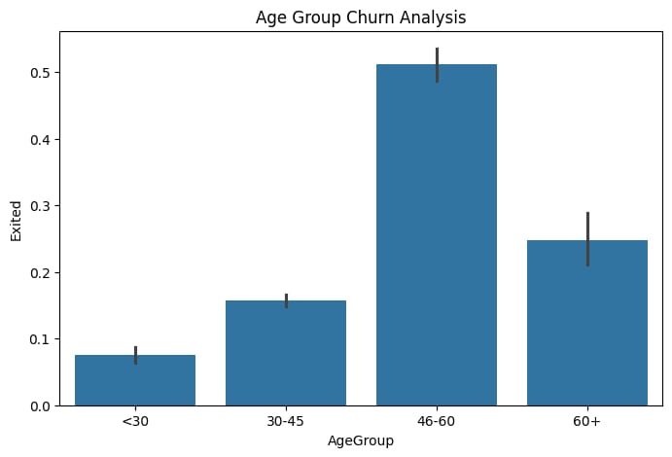

Interpretation
The chart demonstrates churn patterns across different age groups. Customers aged between 46 and 60 years exhibit the highest churn rate among all segments. Younger customers, particularly those below 30 years, are less likely to leave the bank. This suggests that churn tendency increases with age. Banks should focus on addressing the specific needs of middle-aged and older customers to improve retention.

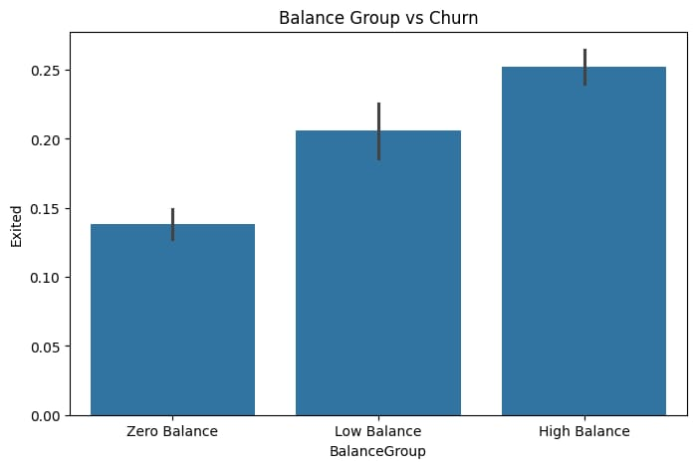

Interpretation
The chart analyzes customer churn based on account balance categories. Customers with higher account balances display a greater likelihood of leaving the bank. This is a significant concern because high-balance customers contribute substantial value to the organization. Customers with low or zero balances show comparatively lower churn rates. Therefore, the bank should develop targeted loyalty programs to retain high-value customers.

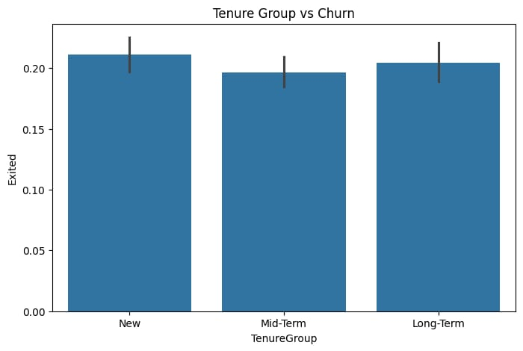

Interpretation
The chart examines churn behavior across different customer tenure groups. Churn is observed among new, mid-term, and long-term customers, with only minor differences between categories. This indicates that tenure alone does not strongly influence customer exit decisions. Other factors such as customer activity, age, and account balance may play a more important role. Banks should consider multiple variables when designing retention strategies rather than relying solely on tenure.

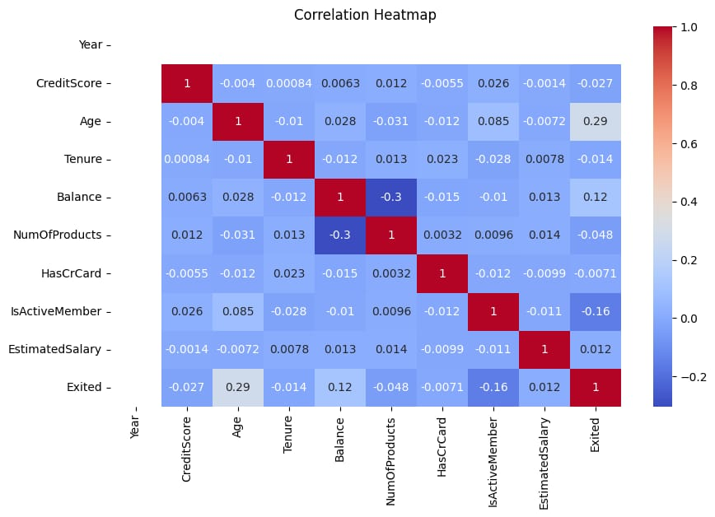
Interpretation
The correlation heatmap shows the relationships between customer attributes and churn. Age has a positive correlation with churn, indicating that older customers are more likely to leave the bank. Active membership displays a negative correlation, suggesting that engaged customers tend to remain with the bank. Most other variables show weak correlations, meaning no single factor completely explains churn behavior. The results highlight the need for a comprehensive approach that considers multiple customer characteristics simultaneously.

CONCLUSION
The study on Customer Segmentation and Churn Pattern Analytics in European Banking successfully identified important customer segments and analyzed the factors influencing customer churn. The findings revealed that geography, age, account balance, tenure, and customer activity status significantly affect churn behavior, with higher churn observed among customers from Germany, inactive members, older customers, and high-balance account holders. The analysis demonstrates that customer segmentation is an effective approach for understanding customer behavior and supporting data-driven decision-making. By leveraging these insights, banks can implement targeted retention strategies, enhance customer engagement, improve service quality, and strengthen long-term customer relationships, ultimately reducing customer attrition and increasing overall profitability.

